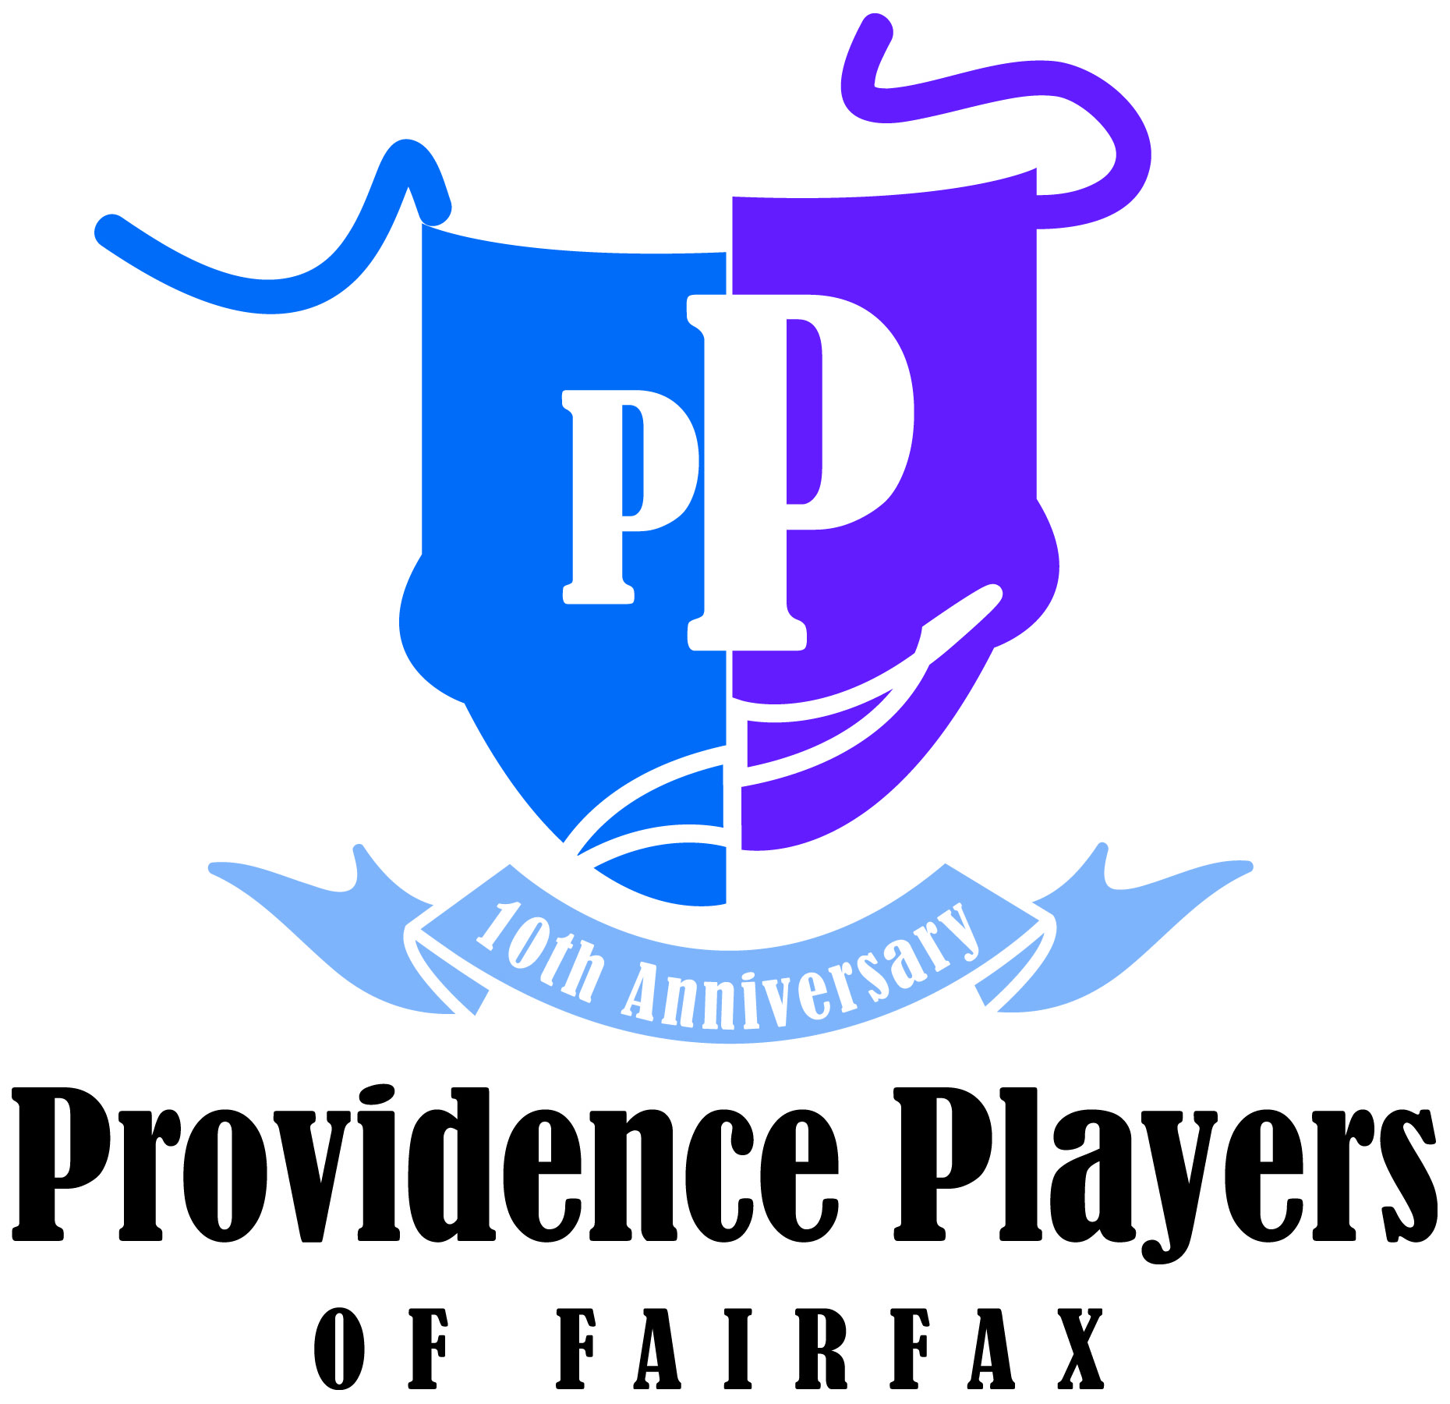 |  |  | Free Ticket Program  Theatre Community Inclusion Project
Recognizing not everyone can afford the cost of admission, PPF provides free tickets to organizations that serve underserved young people and their families. A limited number of tickets are available for each performance and tickets are distributed to qualified organizations on a first come, first served basis. All other ticket policies apply. For more information, please visit our website at www.providenceplayers.org

To qualify, you must represent a legitimate non-profit organization, government agency or school that supports underserved youth.

SECTION A: Contact Information
Name of Individual |  |  |  |  |  | PPF Member? | Yes No
Qualifying Organization |  |  |  |  |  | Phone | Home:  Work:  Cell:
Full Address |  |  |  |  |  | Phone | Home:  Work:  Cell:
E-Mail 1 |  |  |  |  | Email 2
SECTION B: Show and Ticket Information
Production | Show Date Requested |  |  | # of Tickets | Accommodations (e.g., disabled)
Mainstage Show
Holiday Show
Workshop
Other Event
SECTION C: Additional Information or Requests

Please submit your form by emailing it to tickets@providenceplayers.org. (If you are a new non-profit organization submitting this request for the first time, please attach a scanned copy of your 501(c)(3) IRS determination letter.) Thank you.

